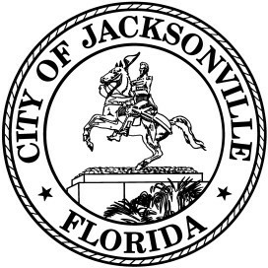
OFFICE OF THE CITY COUNCIL

Office (904) 255-5200 117 West Duval Street
Fax (904) 255-5230 City Hall, Suite 425
Jacksonville, FL 32202

Zoom Virtual Noticed Town Hall Meeting
Council members Carlucci and Cumber- Re Lot J
November 24, 2020
Zoom Meeting ID: 968 1700 0324
Zoom Meeting Passcode: 217086

Agenda

- Introductions

- Proposed legislation – CM Carlucci

- Proposed legislation – CM Cumber

- Council Members Discussion

- Public Comments (if time is available)

- Adjourn

.

